Manhua (漫画 / 滿畫)

Definition
# Source: Chatgpt (GPT-5-Standard) at [10/28/2025]
Manhua is the Chinese term for comics or graphic novels, similar to:
- 🇯🇵 Manga (Japanese comics)
- 🇰🇷 Manhwa (Korean comics)
So basically, Manhua = Chinese Comics.

Key Features of Manhua:
# Source: Chatgpt (GPT-5-Standard) at [10/28/2025]
Feature | Description
Origin | China 🇨🇳, Hong Kong 🇭🇰, and Taiwan 🇹🇼
Language | Simplified or Traditional Chinese
Reading Direction | Usually left → right (like English)
Art Style | Often full-color and digitally illustrated, more like manhwa than black-and-white manga
Format | Can be printed or released online as webcomics / webtoons
Themes | Wide variety — action, fantasy, romance, cultivation (xianxia), historical, and martial arts
Target Audience | Children to adults, depending on story and tone

Famous Manhua Examples:
# Source: Chatgpt (GPT-5-Standard) at [10/28/2025]
Title | Genre | Description
The King’s Avatar (全职高手) | Action / E-sports | A pro gamer returns to dominate the online world
Tales of Demons and Gods (妖神记) | Fantasy / Cultivation | A reborn warrior tries to rewrite destiny
Soul Land (斗罗大陆 / Douluo Dalu) | Fantasy | A young boy trains in a magical martial world
Feng Shen Ji (封神纪) | Mythology / Action | Gods and humans battle for control of heaven
19 Days | Slice of Life / Comedy | Follows friendship and romance between two boys

Comics vs. Manga vs. Manhwa vs. Manhua (Structure & Publication)
# Source: Chatgpt (GPT-5-Standard) at [10/28/2025]
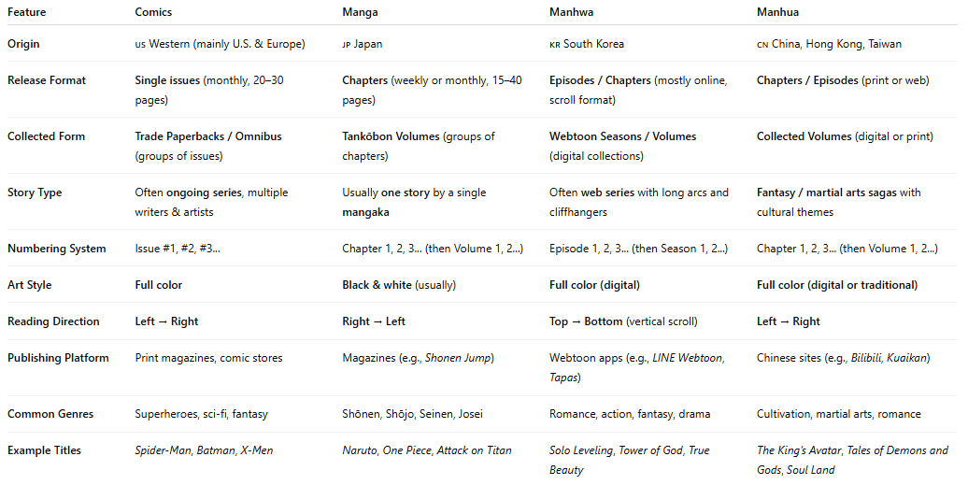
Feature | Comics | Manga | Manhwa | Manhua
Origin | 🇺🇸 Western (mainly U.S. & Europe) | 🇯🇵 Japan | 🇰🇷 South Korea | 🇨🇳 China, Hong Kong, Taiwan
Release Format | Single issues (monthly, 20–30 pages) | Chapters (weekly or monthly, 15–40 pages) | Episodes / Chapters (mostly online, scroll format) | Chapters / Episodes (print or web)
Collected Form | Trade Paperbacks / Omnibus (groups of issues) | Tankōbon Volumes (groups of chapters) | Webtoon Seasons / Volumes (digital collections) | Collected Volumes (digital or print)
Story Type | Often ongoing series, multiple writers & artists | Usually one story by a single mangaka | Often web series with long arcs and cliffhangers | Fantasy / martial arts sagas with cultural themes
Numbering System | Issue #1, #2, #3... | Chapter 1, 2, 3... (then Volume 1, 2...) | Episode 1, 2, 3... (then Season 1, 2...) | Chapter 1, 2, 3... (then Volume 1, 2...)
Art Style | Full color | Black & white (usually) | Full color (digital) | Full color (digital or traditional)
Reading Direction | Left → Right | Right → Left | Top → Bottom (vertical scroll) | Left → Right
Publishing Platform | Print magazines, comic stores | Magazines (e.g., Shonen Jump) | Webtoon apps (e.g., LINE Webtoon, Tapas) | Chinese sites (e.g., Bilibili, Kuaikan)
Common Genres | Superheroes, sci-fi, fantasy | Shōnen, Shōjo, Seinen, Josei | Romance, action, fantasy, drama | Cultivation, martial arts, romance
Example Titles | Spider-Man, Batman, X-Men | Naruto, One Piece, Attack on Titan | Solo Leveling, Tower of God, True Beauty | The King’s Avatar, Tales of Demons and Gods, Soul Land

In Short:
# Source: Chatgpt (GPT-5-Standard) at [10/28/2025]
🧠 Manhua = Chinese comics, often colorful, digital, and focused on fantasy, martial arts, or romance themes.
It’s the Chinese counterpart of Japanese manga and Korean manhwa.

